Name: M.KASIF JALAL
Reg No: 192424214

EXP NO 1:

CREATE A SIMPLE CLOUD SOFTWARE APPLICATION FOR FLIGHT RESERVATION SYSTEM USING ANY CLOUD SERVICE PROVIDER TO DEMONSTRATE SAAS.

AIM:
To create a simple cloud software application for flight reservation system using any cloud service provider to demonstrate saas.
PROCEDURE: step1: Go to zoho.com. step 2: Log into the zoho.com. step 3: Select one application step. step4: Enter application name as flight reservation system. step 5: Created new application flight reservation system. step 6: Select one form step 7: The software has been created

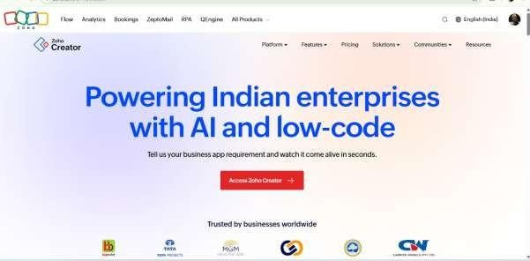
IMPLEMENTATION: STEP1: GOTO ZOHO.COM

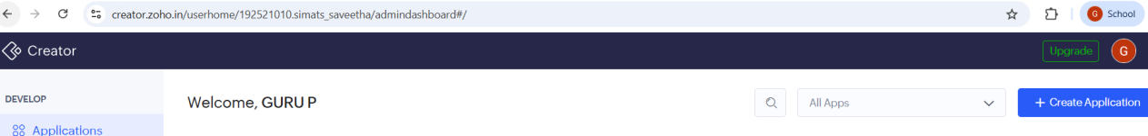
STEP 2: LOGINTOTHE ZOHO.COM

STEP 3: SELECT ONE APPLICATION

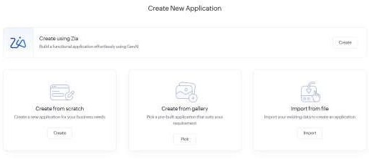

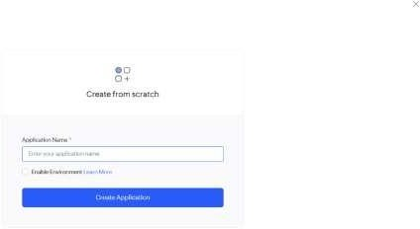
STEP 4: ENTER APPLICATION NAME

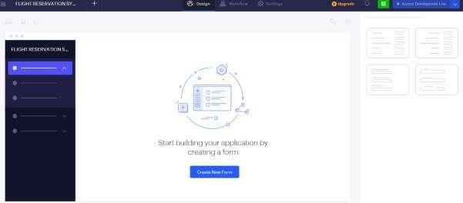
STEP 5: CREATED NEW APPLICATION

STEP 6: SELECT ONE FORM

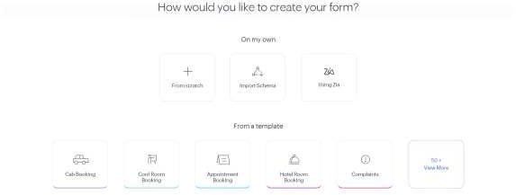
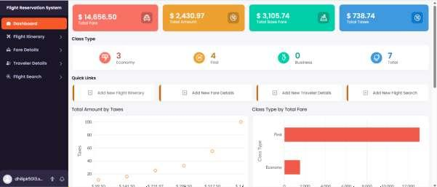
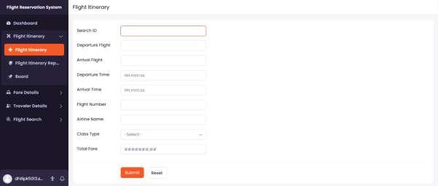
STEP 7: THE SOFTWARE HASE BEEN CREATED.

EXP NO 2:

CREATE A SIMPLE CLOUD SOFTWARE APPLICATION FOR PROPERTY BUYING & RENTAL PROCESS (IN CHENNAI CITY) USING ANY CLOUD SERVICE PROVIDER TO DEMONSTRATE SAAS.

AIM: To Create a simple cloud software application for Property Buying & Rental process (In Chennai city) using any Cloud Service Provider to demonstrate SaaS.

PROCEDURE: step1: Go to zoho.com. step 2: Log into the zoho.com. step 3:
Select one application step. step4: Enter application name as property buying &
rental. step 5: Created new application as property buying & rental. step 6: Select one form step 7: The software has been created.

IMPLEMENTATION:


STEP1: GOTO ZOHO.COM
STEP 2: LOGINTOTHE ZOHO.COM



STEP 3: SELECT ONE APPLICATION




STEP 4: ENTER APPLICATION NAME


STEP 5: CREATED NEW APPLICATION

STEP 6: SELECT ONE FORM


STEP 7: THE SOFTWARE HASE BEEN CREATED.

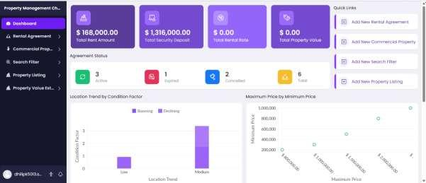
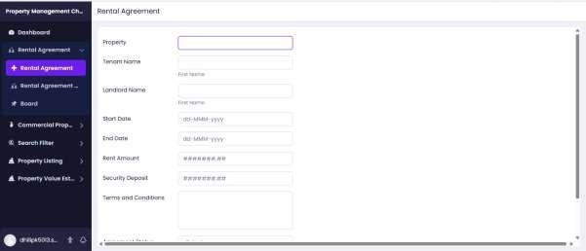

EXP NO 3:

CREATE A SIMPLE CLOUD SOFTWARE APPLICATION FOR CAR BOOKING RESERVATION SYSTEM USING ANY CLOUD SERVICE PROVIDER TO DEMONSTRATE SAAS.

AIM: To Create a simple cloud software application for Car Booking Reservation System using any Cloud Service Provider to demonstrate SaaS.

PROCEDURE: step1: Go to zoho.com. step 2: Log into the zoho.com. step 3: Select one application step. step4: Enter
application name as Car Booking Reservation System. step 5:
Created new application as Car Booking Reservation System. step 6: Select one form step 7: The software has been created.


IMPLEMENTATION: STEP1: GOTO ZOHO.COM

STEP 2: LOGINTOTHE ZOHO.COM


STEP 3: SELECT ONE APPLICATION




STEP 4: ENTER APPLICATION NAME


STEP 5: CREATED NEW APPLICATION

STEP 6: SELECT ONE FORM


STEP 7: THE SOFTWARE HASE BEEN CREATED.

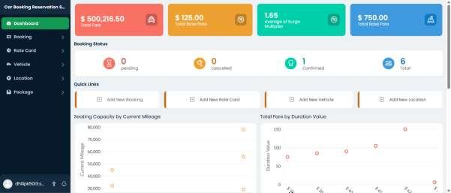
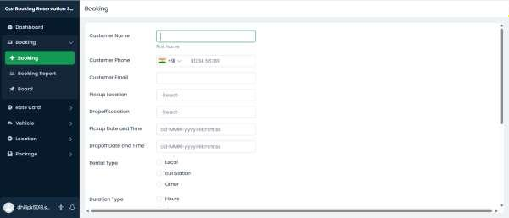

EXP NO 4:

CREATE A SIMPLE CLOUD SOFTWARE APPLICATION FOR LIBRARY BOOK RESERVATION SYSTEM FOR SIMATS LIBRARY USING ANYCLOUD SERVICE PROVIDER TO DEMONSTRATE SAAS

AIM: To Create a simple cloud software application for Library book reservation system for SIMATS library using any Cloud Service Provider to demonstrate SaaS

PROCEDURE: step1: Go to zoho.com. step 2: Log into the zoho.com. step 3: Select one application step. step4: Enter
application name as library book reservation system. step 5:
Created new application as library book reservation system. step 6: Select one form s tep 7: The software has been created.


IMPLEMENTATION: STEP1: GOTO ZOHO.COM

STEP 2: LOGINTOTHE ZOHO.COM


STEP 3: SELECT ONE APPLICATION




STEP 4: ENTER APPLICATION NAME

STEP 5: CREATED NEW APPLICATION

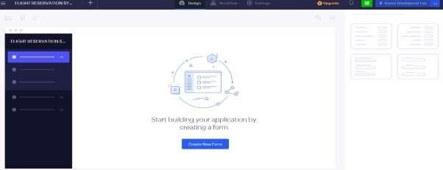

STEP 6: SELECT ONE FORM


STEP 7: THE SOFTWARE HASE BEEN CREATED.

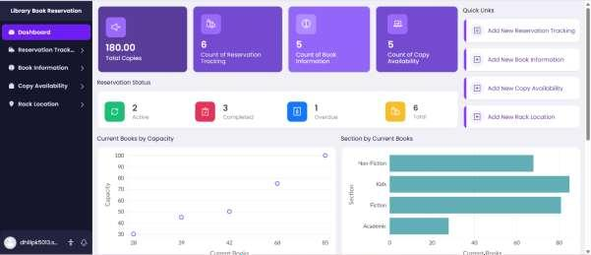
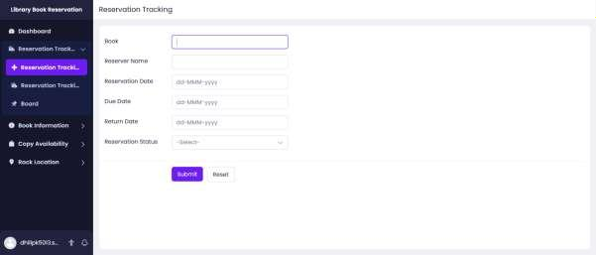

EXP NO 5:
CREATE A SIMPLE CLOUD SOFTWARE APPLICATION FOR MARK SHEET PROCESSING SYSTEM USING ANY CLOUD SERVICE PROVIDER TO
DEMONSTRATE SAAS INCLUDE THE NECESSARY FIELDS SUCH AS NAME OF THE STUDENT, REG NO OF THE STUDENT, SUBJECTS, MARKS, AVERAGE, PERCENTAGE, RANK, OVERALL PERFORMANCE ETC.

AIM:
To create a simple cloud software application for Mark Sheet Processing System using Zoho Creator as a Cloud Service Provider to demonstrate the Software as a Service (SaaS) model.

PROCEDURE:
Step 1: Go to zoho.com.
Step 2: Log in to your Zoho account.
Step 3: Open Zoho Creator from the Zoho applications.

Step 4: Click Create New Application.
Step 5: Enter the application name as Mark Sheet Processing System. Step 6: Create a new application.
Step 7: Create a new form named Student Details.
Step 8: Save the application and test it by entering sample student details and marks.
Step 9: The Mark Sheet Processing System software has been successfully created and deployed on the Zoho cloud platform.


IMPLEMENTATION: STEP1: GOTO ZOHO.COM

STEP 2: LOGINTOTHE ZOHO.COM


STEP 3: SELECT ONE APPLICATION



STEP 4: ENTER APPLICATION NAME

STEP 5: CREATED NEW APPLICATION



STEP 6: SELECT ONE FORM


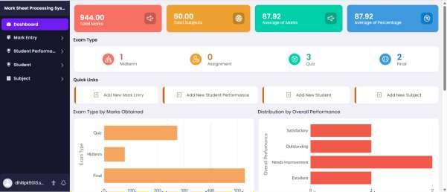
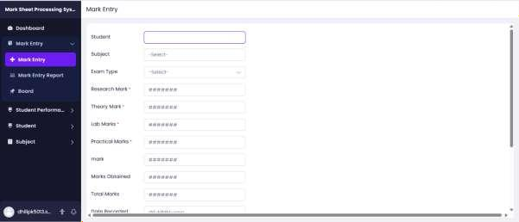
STEP 7: THE SOFTWARE HASE BEEN CREATED.

EXP NO 6:
CREATE A SIMPLE CLOUD SOFTWARE APPLICATION FOR PAYROLL PROCESSING SYSTEM USING ANY CLOUD SERVICE PROVIDER TO
DEMONSTRATE SAAS INCLUDE THE NECESSARY FIELDS SUCH AS NAME OF THE EMPLOYEE, EXPERIENCE IN PRESENT ORG, OVER ALL
EXPERIENCE, BASIC PAY, HRA, DA, TA, NET PAY, GROSS PAY ETC.

AIM:
To create a simple cloud software application for Payroll Processing System using Zoho Creator as a Cloud Service Provider to demonstrate the Software as a Service (SaaS) model.

PROCEDURE:
Step 1: Go to zoho.com.
Step 2: Log in to your Zoho account.
Step 3: Open Zoho Creator from the Zoho applications.

Step 4: Click Create New Application.
Step 5: Enter the application name as Payroll Processing System. Step 6: Create a new application.
Step 7: Create a new form named Employee Payroll Details.
Step 8: The Payroll Processing System software has been successfully created and deployed on the Zoho cloud platform.


IMPLEMENTATION: STEP1: GOTO ZOHO.COM

STEP 2: LOGINTOTHE ZOHO.COM



STEP 3: SELECT ONE APPLICATION



STEP 4: ENTER APPLICATION NAME


STEP 5: CREATED NEW APPLICATION

STEP 6: SELECT ONE FORM

STEP 7: THE SOFTWARE HASE BEEN CREATED.
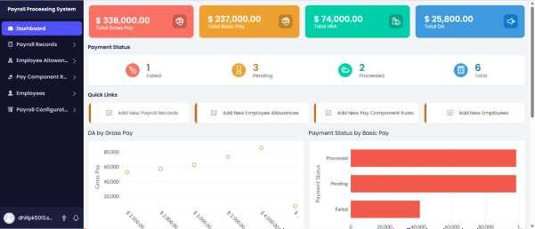
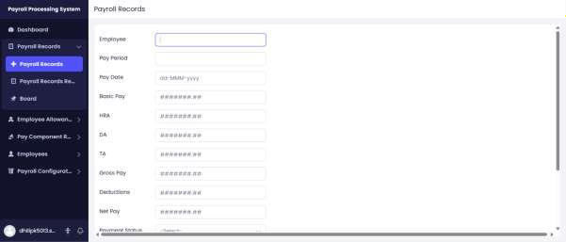

EXP NO 7:

CREATE A SIMPLE CLOUD SOFTWARE APPLICATION FOR STUDENTS ATTENDANCE SYSTEM USING ANY CLOUD SERVICE PROVIDER TO DEMONSTRATE SAAS INCLUDE THE NECESSARY FIELDS SUCH AS NAME OF THE STUDENTS, COURSE, PRESENT, ABSENT, COURSE ATTENDANCE, OD REQUEST, GRADE, ATTENDANCE PERCENTAGE, ETC.

AIM:
To create a simple cloud software application for Students Attendance System using Zoho Creator as a Cloud Service Provider to demonstrate the Software as a Service (SaaS) model.

PROCEDURE:
Step 1: Go to zoho.com.
Step 2: Log in to your Zoho account.
Step 3: Open Zoho Creator from the Zoho applications.

Step 4: Click Create New Application.
Step 5: Enter the application name as Students Attendance System. Step 6: Create a new application.
Step 7: Create a new form named Student Attendance Details.
Step 10: Create reports to display student attendance details, attendance percentage, and grade.
Step 11: Save the application and test it by entering sample student attendance records.
Step 13: The Students Attendance System software has been successfully created and deployed on the Zoho cloud platform.


IMPLEMENTATION: STEP1: GOTO ZOHO.COM

STEP 2: LOGINTOTHE ZOHO.COM



STEP 3: SELECT ONE APPLICATION



STEP 4: ENTER APPLICATION NAME


STEP 5: CREATED NEW APPLICATION
STEP 6: SELECT ONE FORM


STEP 7: THE SOFTWARE HASE BEEN CREATED.
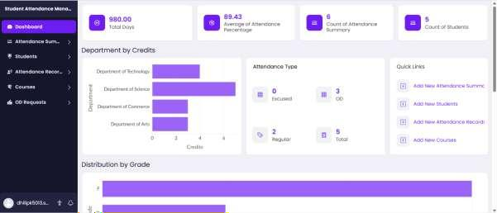
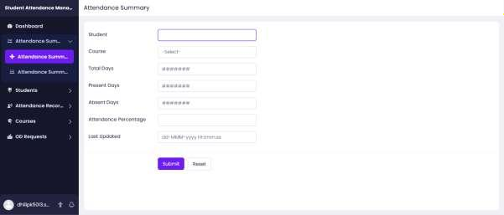

EXP.NO : 8
DEMONSTRATE SAAS WITH THE FIELDS OF STUDENT NAME, AGE, ADDRESS,PHONE, SUBJECTS STUDIED, YEAR OF PASSING, PERCENTAGE OF MARKS, DOMAIN INTEREST, ETC.

AIM:
To create a simple cloud web application for Student Counselling System using Zoho Creator as a Cloud Service Provider to demonstrate the Software as a Service (SaaS) model.

PROCEDURE:
Step 1: Go to zoho.com.
Step 2: Log in to your Zoho account.
Step 3: Open Zoho Creator from the Zoho applications.

Step 4: Click Create New Application.
Step 5: Enter the application name as Student Counselling System. Step 6: Create a new application.
Step 7: Create a new form named Student Counselling Details.
Step 12: Verify that the student information is stored correctly and the reports display the required details.
Step 13: The Student Counselling System software has been successfully created and deployed on the Zoho cloud platform.


IMPLEMENTATION: STEP1: GOTO ZOHO.COM

STEP 2: LOGINTOTHE ZOHO.COM



STEP 3: SELECT ONE APPLICATION



STEP 4: ENTER APPLICATION NAME

STEP 5: CREATED NEW APPLICATION



STEP 6: SELECT ONE FORM

STEP 7: THE SOFTWARE HASE BEEN CREATED.
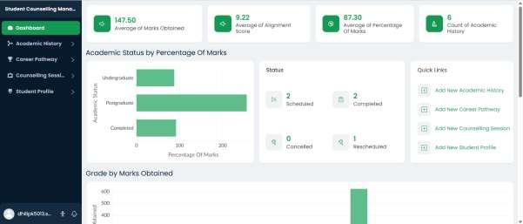

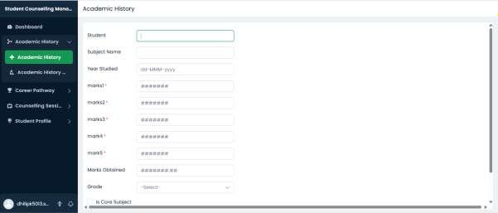

EXP NO 9:

CREATE A SIMPLE CLOUD SOFTWARE APPLICATION FOR HOSPITAL INFORMATION SYSTEM FOR SIMATS HOSPITAL USING ANY CLOUD SERVICE PROVIDER TO DEMONSTRATE SAAS WITH FIELDS OF PATIENT NAME, AGE, ADDRESS, PHONE, EMAIL, ATTENDER NAME, ATTENDER PHONE, DOCTOR NAME, DISEASES, ETC.

AIM:
To create a simple cloud software application for Hospital Information System for SIMATS Hospital using Zoho Creator as a Cloud Service Provider to demonstrate the Software as a Service (SaaS) model.

PROCEDURE:
Step 1: Go to zoho.com.
Step 2: Log in to your Zoho account.
Step 3: Open Zoho Creator from the Zoho applications.

Step 4: Click Create New Application.
Step 5: Enter the application name as Hospital Information System. Step 6: Create a new application.
Step 7: Create a new form named Patient Information.
Step 9: Configure the form to store and manage patient information securely.
Step 10: Create reports to display patient details, doctor information, and treatment records.
Step 11: Save the application and test it by entering sample patient details.
Step 12: Verify that all patient information is stored correctly and the reports display the required details.
Step 13: The Hospital Information System software has been successfully created and deployed on the Zoho cloud platform.


IMPLEMENTATION: STEP1: GOTO ZOHO.COM

STEP 2: LOGINTOTHE ZOHO.COM



STEP 3: SELECT ONE APPLICATION



STEP 4: ENTER APPLICATION NAME

STEP 5: CREATED NEW APPLICATION



STEP 6: SELECT ONE FORM

STEP 7: THE SOFTWARE HASE BEEN CREATED.
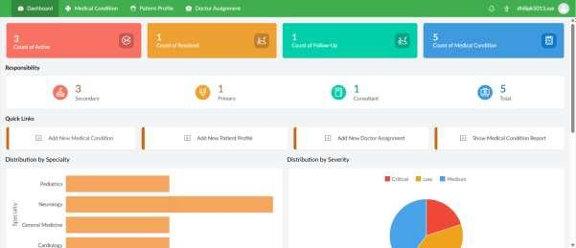

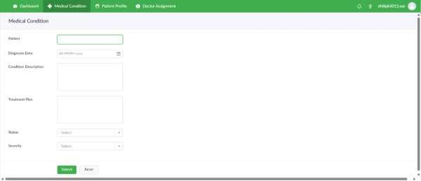

EXP NO 10:
CREATE A SIMPLE CLOUD SOFTWARE APPLICATION TO RUN A C PROGRAM TO DISPLAY THE STUDENT INFORMATION USING ANY CLOUD SERVICE PROVIDER TO DEMONSTRATE SAAS WITH THE TEMPLATE OF STUDENT NAME, REG NO, ADDRESS, PHONE, AGE, COURSES, GRADES AND ATTENDANCE REPORT, PROGRESS REPORT, SEMESTER MARK SHEET
FORMS

AIM:
To create a simple cloud software application to run a C program for displaying student information using Zoho Creator as a Cloud Service Provider to demonstrate the Software as a Service (SaaS) model.

PROCEDURE:
Step 1: Go to zoho.com.
Step 2: Log in to your Zoho account.
Step 3: Open Zoho Creator from the Zoho applications.

Step 4: Click Create New Application.
Step 5: Enter the application name as Student Information System. Step 6: Create a new application.
Step 7: Create a new form named Student Information.

Step 8: Add the required fields such as Student Name, Register Number, Address, Phone Number, Age, Courses, Grades, Attendance Report, Progress Report, and Semester Mark Sheet.
Step 9: Create reports to display the entered student information, attendance report, progress report, and semester mark sheet.
Step 10: Save the application and test it by entering sample student details.
Step 11: Verify that the application correctly stores and displays the student information and reports.
Step 12: The Student Information System software has been successfully created and deployed on the Zoho cloud platform, demonstrating the Software as a Service (SaaS) model.

IMPLEMENTATION: STEP1: GOTO ZOHO.COM



STEP 2: LOGINTOTHE ZOHO.COM


STEP 3: SELECT ONE APPLICATION


STEP 4: ENTER APPLICATION NAME




STEP 5: CREATED NEW APPLICATION

STEP 6: SELECT ONE FORM


STEP 7: THE SOFTWARE HASE BEEN CREATED.

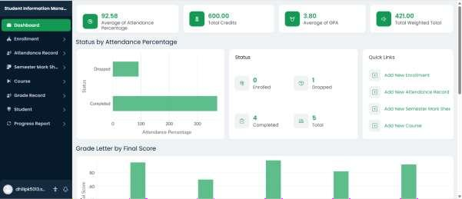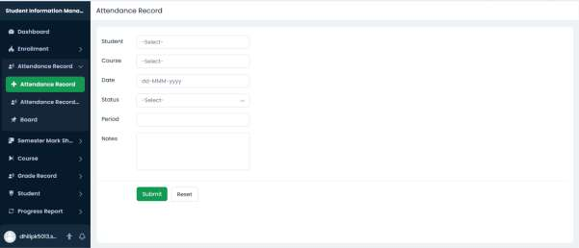

EXP NO 11:

CREATE A SIMPLE CLOUD SOFTWARE APPLICATION FOR ONLINE SUPER MARKET USING ANY CLOUD SERVICE PROVIDER TO DEMONSTRATE SAAS WITH THE TEMPLATE OF CUSTOMER NAME, ADDRESS, PHONE, EMAIL, ITEMS, QUANTITY ETC. WITH THE ITEM CLASSIFICATION FORM.

AIM:
To create a simple cloud software application for Online Supermarket using Zoho Creator as a Cloud Service Provider to demonstrate the Software as a Service (SaaS) model.

PROCEDURE:
Step 1: Go to zoho.com.
Step 2: Log in to your Zoho account.
Step 3: Open Zoho Creator from the Zoho applications.

Step 4: Click Create New Application.
Step 5: Enter the application name as Online Supermarket. Step 6: Create a new application.
Step 7: Create a new form named Customer Order Details.

Step 8: Add the required fields such as Customer Name, Address, Phone Number, Email, Item Name, Item Category (Classification), Quantity, Unit Price, Total Amount, and Payment Status.
Step 9: Create an Item Classification form to categorize items such as Groceries, Fruits & Vegetables, Dairy Products, Beverages, Snacks, Household Items, and Personal Care. Step 10: Configure formula fields to calculate the Total Amount based on the Quantity and Unit Price.
Step 11: Create reports to display customer orders, item classifications, and billing details.
Step 12: Save the application and test it by entering sample customer and order details. Step 13: Verify that the application correctly stores customer information, classifies items, calculates the total amount, and displays the reports.
Step 14: The Online Supermarket software has been successfully created and deployed on the Zoho cloud platform.

IMPLEMENTATION: STEP1: GOTO ZOHO.COM




STEP 2: LOGINTOTHE ZOHO.COM

STEP 3: SELECT ONE APPLICATION




STEP 4: ENTER APPLICATION NAME


STEP 5: CREATED NEW APPLICATION

STEP 6: SELECT ONE FORM

STEP 7: THE SOFTWARE HASE BEEN CREATED.

